For Residential Real Estate Brokers and Salespeople
www.worldrealestatenetwork.com

At Real Estate Board Shows we have one of the busiest booths because we make
a statement that you could have a $30,000 web site and it would not be as powerful
as the one supplied by ICIWorld for $199/year. Yet we recommend you keep all your sites!
- Web sites are like billboards, if they all generate leads why not? WE HELP YOU WITH ALL OF THEM.
- The difference from other web sites is that not only is it a professional $5000-$10,000 looking website, but it will have thousands of listings with colour photos, slide show displays automatic updating.
- The difference from other web sites is that all listings are specially structured so that YOU GET THE CALLS! It is like having thousands of classified ads but in a way that you get the calls.
- Do referrals. Do direct business. Make appointments!
- THIS WEBSITE IS NOW MOBILIZED Take advantage of the new Internet Revolution!
- AUTOMATIC! Delivery of new listings to prospects. They see a home in an email . . . they call you!
- We provide commercial links for all your web sites so you can DO REFERRALS!
- SEO Search Engine Optimization! What good is a web site without traffic? We help you with traffic.
- Access to powerful training and search engine optimization, exclusive to members to forty different ways to promote your website, help videos, web site support, powerful listing tools, and more!
- You will now generate leads from your website! You can work these leads as referrals! One Re/max agent has done 15 referrals. That is 75 minutes of his time. He made over $45,000. The only reason brokers do not do referrals is because they do not get the leads. Now you will!
- Retired brokers program: Would you mind doing the odd five minute referral that makes you $3,000-$10,000? Let the website work for you for the rest of your life so you don’t have to!

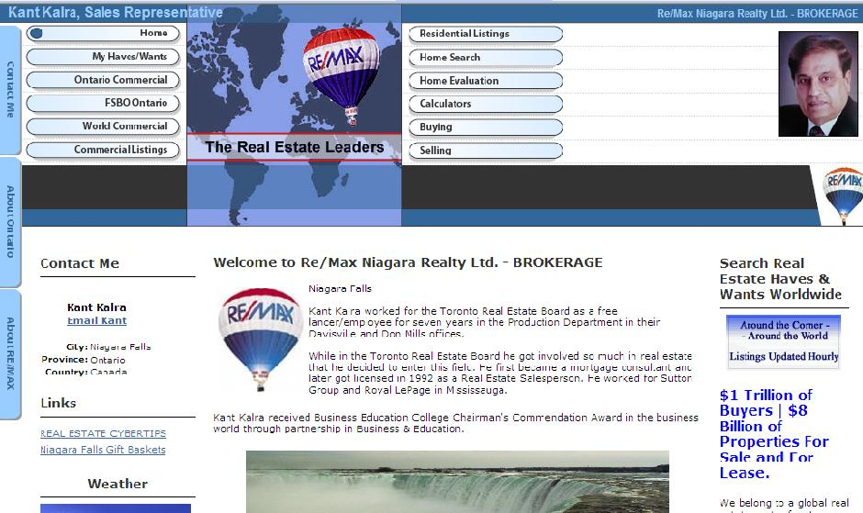

See more sample web sites at www . iciworld.com click on For Members

Website features: Designed to Trigger Calls off the Internet
- beautiful listings displays (slide show format) virtual tours | - domain name management  - many design options | - it is absolutely inevitable that everyone does business
- mobilized websites mean people can see you site properly from their mobile phones world wide. | - website blogs  - performance summaries  - electronic listing brochures | - exposure in google  - you have control  - searches, mortgage calculators
Telephone technical support. We totally set up your first web site so it can work to make you money. They are totally customizable by you and we show you how. We are your assistant.
We provide knowledge to help you make it all work! See success stories of our satisfied members.

$240/yr. + one time $79 signup = 319 + 41.47 HST = $360.47 Web sites are $19.95/mo. after 1 month. (VISA, Mastercard, AMEX, Discover, Interac OnLine, TDCanada Trust) PayPal

The Market ICIWorld Real Estate Network (Since 1994) Toronto, Ontario
Bus. 416-840-6227 After hours, weekends 416-214-4875

